Session 8
4. Test your responsive product card by resizing your browser window and taking screenshots at mobile, tablet, and desktop widths; submit the screenshots along with a short note on what changes at each size.
- Mobile
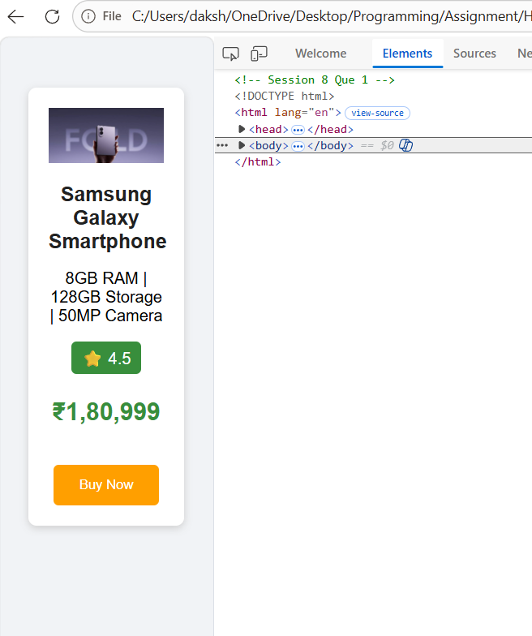

- Tablet
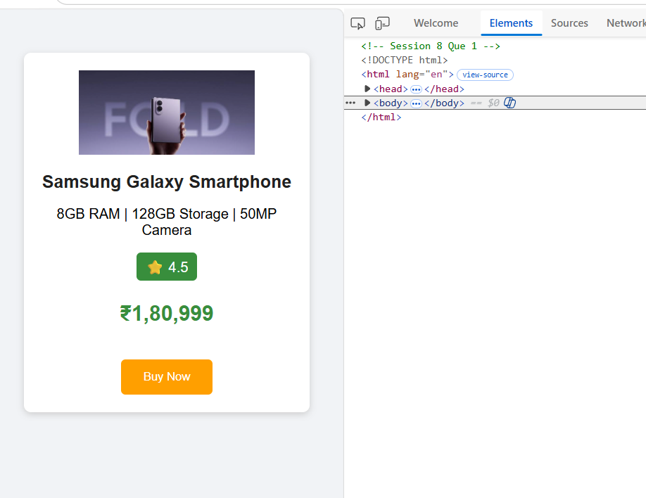

- Laptop
